CYBERSECURITY INTERN REPORT AT SHADOWFOX
Name: P.Nidheshwar
BATCH: ShadowFox Cyber Security October B1
Gmail:nidheshwar1104@gmail.com
TASK LEVEL: Advance level

TASK LEVEL (Advance)
Table of Content

Serial  No | Title | Page No
1. | Using the Tryhackme platform, launch the Basic Pentesting room. Penetrate the room and answer all the questions that are given to you on the website and also create a detailed document of the process of penetration and how you did it.

Table of Contents
Serial  No | Title | Page No
1 | Port scanning | 4-5
2 | Directory Finding | 6
3 | Smb Enumeration | 8-9
4 | Brute force | 10-11
5 | ssh login | 11-12
6 | Privilege escalation | 13-14
7 | Mitigation & recommendations | 15
8 | References | 15

Table of Figure
Figure No | Title | Page No
1.1 | Lab setup (VM IPs) | 1
1.2 | Nmap port scan output | 1
1.3 | Gobuster directory results | 6
1.4 | SMB share listing | 8
1.5 | Hydra brute-force result | 11
1.6 | SSH session login screenshot | 12
1.7 | Privilege escalation evidence | 14

Introduction and information about the report and the machine
Introduction:
In the domain of cybersecurity, it is very important to understand and identify vulnerabilities in web applications to protect them from possible cyber threats. During the Shadowfox internship, a simulated lab environment was provided where different security tasks were performed on sample websites.
Information about the report:

Port scanning :
- Find open services Port scanning and service discovery help find which network services are running on the target. By checking open ports (like 22, 80, 139, 445), we learn which entry points an attacker might use. This step guides the rest of the test by showing which services need closer examination.
Web directory enumeration:
- Web directory enumeration finds hidden pages, backup files, or developer notes on the website. These files often contain useful information such as usernames, hints, or configuration data. Finding and reviewing these pages helps identify weak points and sensitive data exposed on the web server.
SMB enumeration:
- SMB enumeration looks for shared folders and files on the network that may be readable without a password. Anonymous or poorly protected SMB shares can expose backups, credentials, or other sensitive files. Discovering these shares helps show whether file shares leak important information.
Brute forcing:
- Brute forcing uses wordlists and lists of usernames to try common passwords against services like SSH. If weak or reused passwords exist, this method can find valid login credentials. Finding such credentials proves how easily an attacker might gain initial access.
Gaining access:
- After finding valid credentials, we log in to the target to explore the system and collect evidence. We then look for ways to gain higher privileges or access more sensitive files. The final goal is to find the lab’s flag or confirm how an attacker could move deeper into the system.
TASK -1
Using the Tryhackme platform, launch the Basic Pentesting room. Penetrate the room and answer all the questions that are given to you on the website and also create a detailed document of the process of penetration and how you did it.
1.1 Lab Setup:
Attack box (tester VM): Kali Linux (host IPs used in lab).
Target VM: Machine in TryHackMe Basic Pentesting room.
Tools: Nmap, Gobuster, enum4linux, smbclient, Hydra, John the Ripper, ssh2john.
Steps to reproduce with screen shots:
1.2 Step 1:
-Port Scanning & Service Discovery Use Nmap (TCP SYN scan) to enumerate open ports and services on the target.
- nmap 10.201.126.156 -A
- -A --- Aggression scan
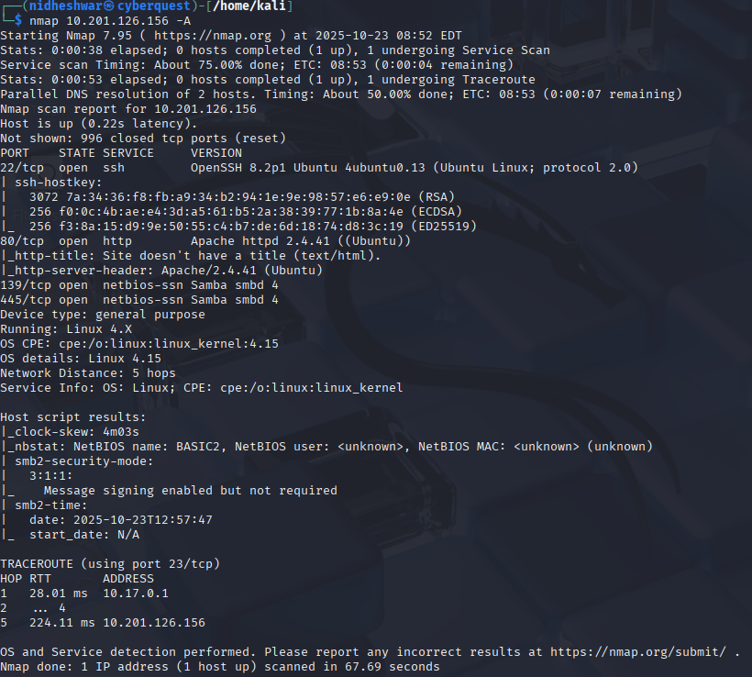

Opening Ports:
- Ssh – 22/tcp
- http – 80/tcp
- netbios-ssn– 139/tcp
- netbios-ssn– 445/tcp
- ajp13 – 8809/tcp
- http – 8080/tcp
Step2 :
HTTP Enumeration:
-Before jumping to any HTTP Enumeration, let’s try first to display the webpage in our browser.

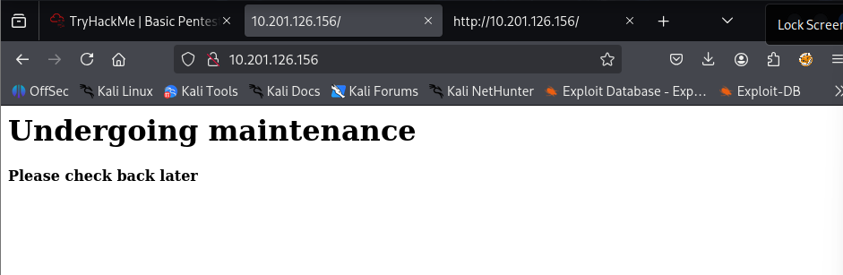
View source Page:
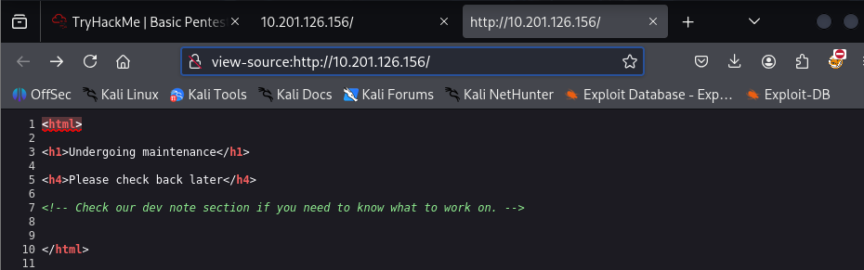
-There’s a small hint here that makes us curious. Let’s go back to the Gobuster directory scan and check it out.
1.3 (Step3) :
Directory Finding:
-I’ll use Gobuster to brute-force enumerate files and directories.

Command:
- gobuster dir -u http://10.201.126.156/ -w /usr/share/wordlists/common.txt

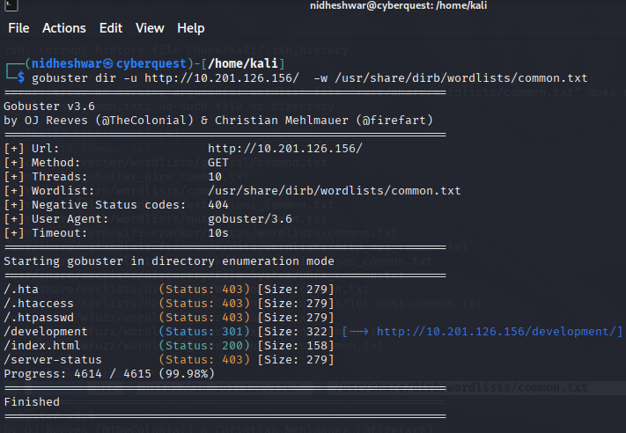
-let’s take a look at this mysterious /development/ directory.and go through that directory you can two .txt file inside directory development.
- dev.txt
- j.txt
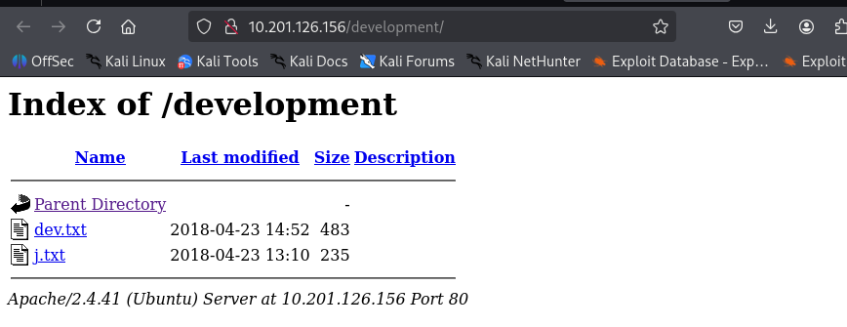
Opening dev.txt:

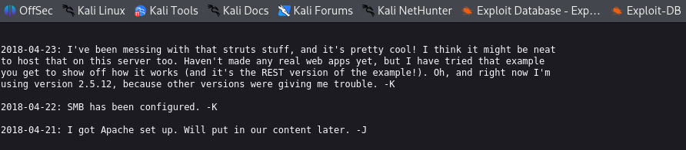
-This text looks like two people (-K and -J), having a conversation. Moreover, they also mentioned things like SMB and Apache server during the conversation.
Opening j.txt:
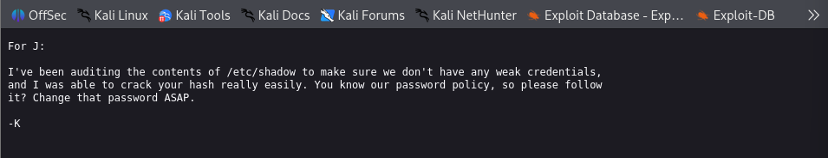
-Interesting, looks like -J doesn’t respect the password policy and he’s using a weak password which is easily crackable.

-after that, In nmap scanning we saw 139,445 port are open so assuming that smb is exits.

1.4 ( Step4 ):
- SMB Enumeration:
To enumerate the SMB server, we will use enum4linux which is the Linux alternative to enum.exe for enumerating data from Windows and Samba hosts.
Command:
-enum4linux -a 10.201.76.124 .
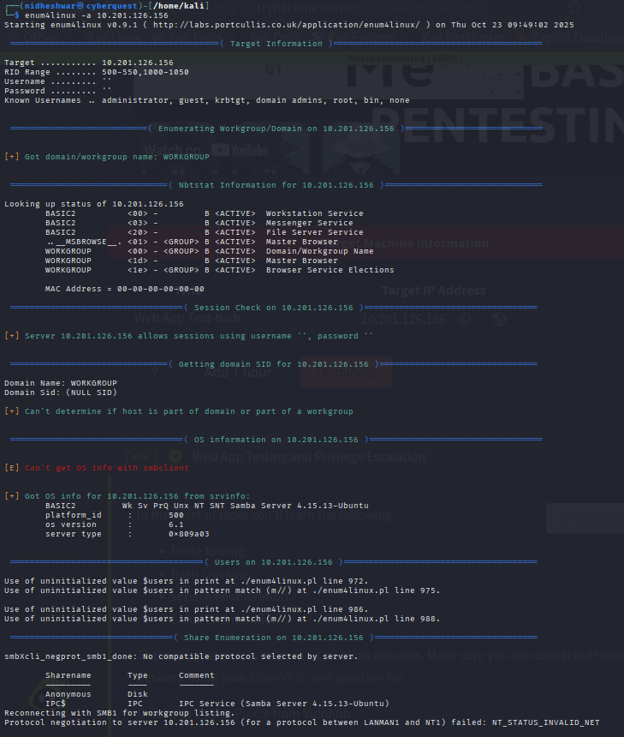

-As you probably notice, we found an anonymous account. An anonymous account is a user account that can access shared folders and files on an SMB server without providing any authentication information.
Command:
-$ smbclient //10.201.126.156/Anonymous
Furthermore, we also found a share, called Anonymous that can be read by anyone.

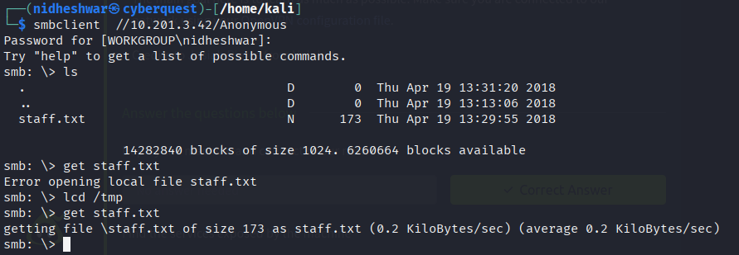

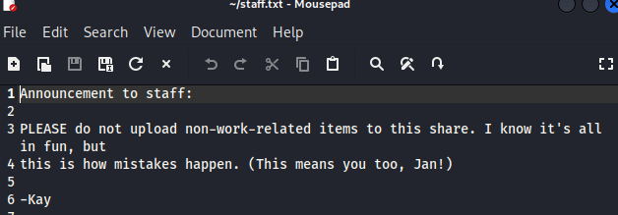
-We found two names (Jan and Kay) that are surely the complete name of -K and -J, we earlier found during the web server enumeration.
-Let’s now try to use all the information we gathered during the enumeration in order to get our first initial access to the target system.
1.5 (Step5) :
- Brute-Forcing SSH credentials:
A tool like Hydra is highly effective for password cracking. Let’s give it a shot.

Command:
-$ hydra -l jan -P /usr/share/wordlists/rockyou.txt -t 4 ssh://10.201.3.42/ -V .

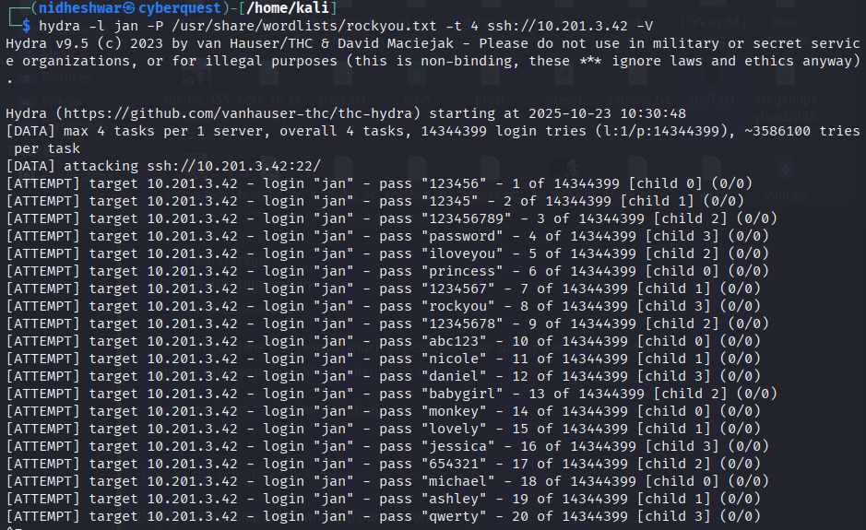

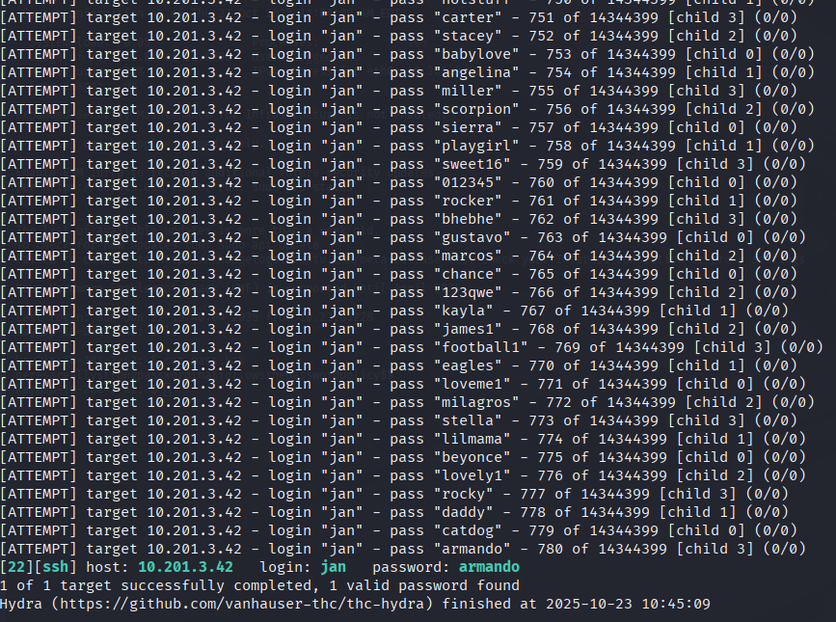
We’ve got the username and password. Now, I’ll log in via SSH.
Username: jan
Password: Armando

1.6 (Step6) :
Ssh Login & Initial Access:
-In this phase, we will try to exploit the potential attack vectors found during the enumeration phase.
- The goal of the exploitation phase is to gain an initial access to the target system. In other words, we’ll try to find an entry point to the target system.
-the target’s SSH port is open and that we have a pair of usernames we can first try to perform a brute force attack.
Command:
-ssh jan@ 10.201.3.42

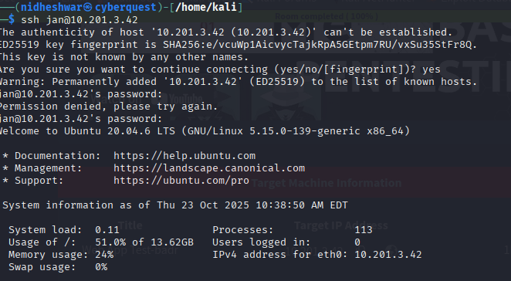

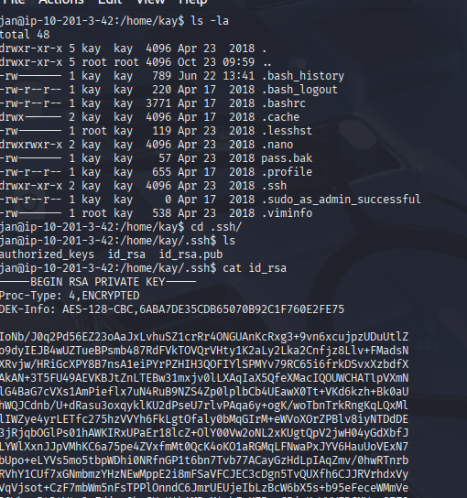
-Copy this key and create an id_rsa file on our machine. I’ll use John the Ripper to crack this SSH hash.

Step6 :
-Privilege escalation:
- find files that hold the final flag.
Command:
-ssh2john id_rsa > hash
- John - - wordlist=usr/share/wordlists/rockyou.txt johnhash

For SSH hashes, you need to use ssh2john to make it easier to crack with John.

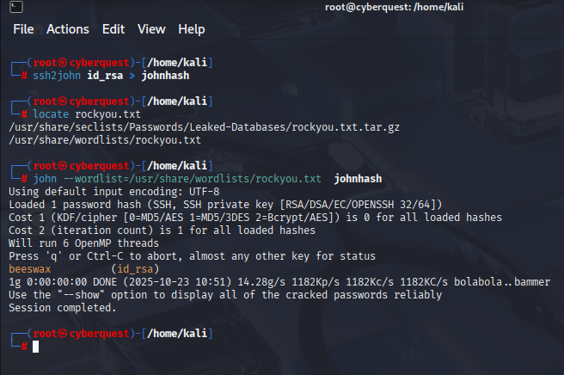
-I’ve got kay’s password. Now, let’s log in via SSH, but this time we’ll switch to the target machine jan.
-Let’s proceed by logging in to SSH on the jan machine.
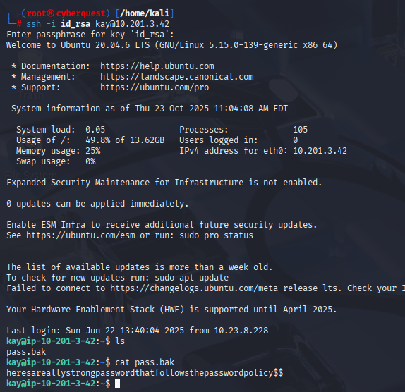
-After successfully logged in to Jay’s account, we can take a look to the different files by using ls -la or ls commands. After doing that, we can see a file name: pass.bak.
-When taking a look at this file’s content, we can see a text which is nothing else than the flag for the last question.

Pass.bak - heresareallystrongpasswordthatfollowsthepasswordpolicy$$

Mitigation & Recommendations:
- Remove sensitive files from webroot (especially /development folder) or restrict HTTP access to configuration or text files.
- Sanitize web content — remove credentials or hints in code or comments.
- Enforce least permissions on home directories and .ssh directories (private keys should have chmod 600 or stricter).
- Disable anonymous SMB share access or restrict to authenticated users.
- Use strong passwords and avoid weak or predictable credentials.

References:
- TryHackMe — Basic Pentesting Room (lab environment).
- OWASP — Network and Web Security testing guidance.
https://owasp.org/
- Enum4linux / smbclient documentation (SMB enumeration tools).
- Hydra documentation (password cracking tool)
- John the Ripper documentation (password cracking).
- Nmap documentation (port scanning).

